Advanced Software Engineering LAB-3

Web Client Using Rest Service

Initially a REST service was created following the tutorial 5 as shown in the screenshots below. The rest service when called with input as <http://localhost:12741/Service2.svc/farh/90> in the browser with 90 Fahrenheit gives Celsius in JSon format with row cel.

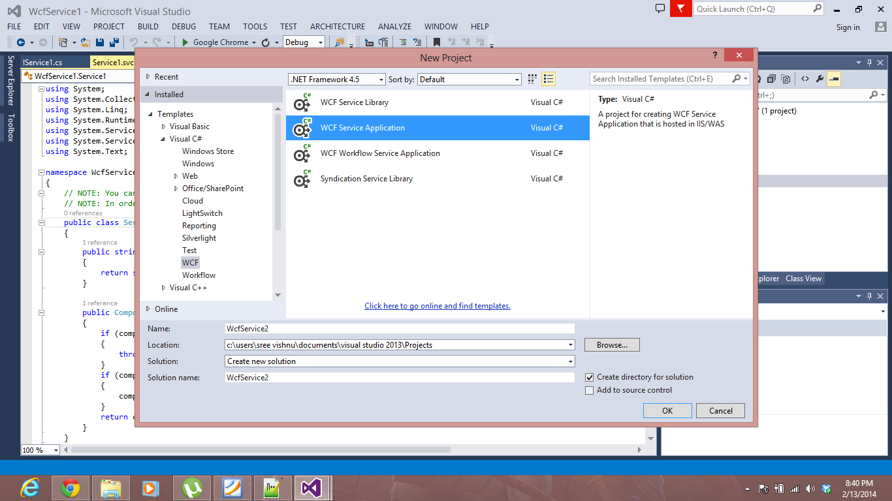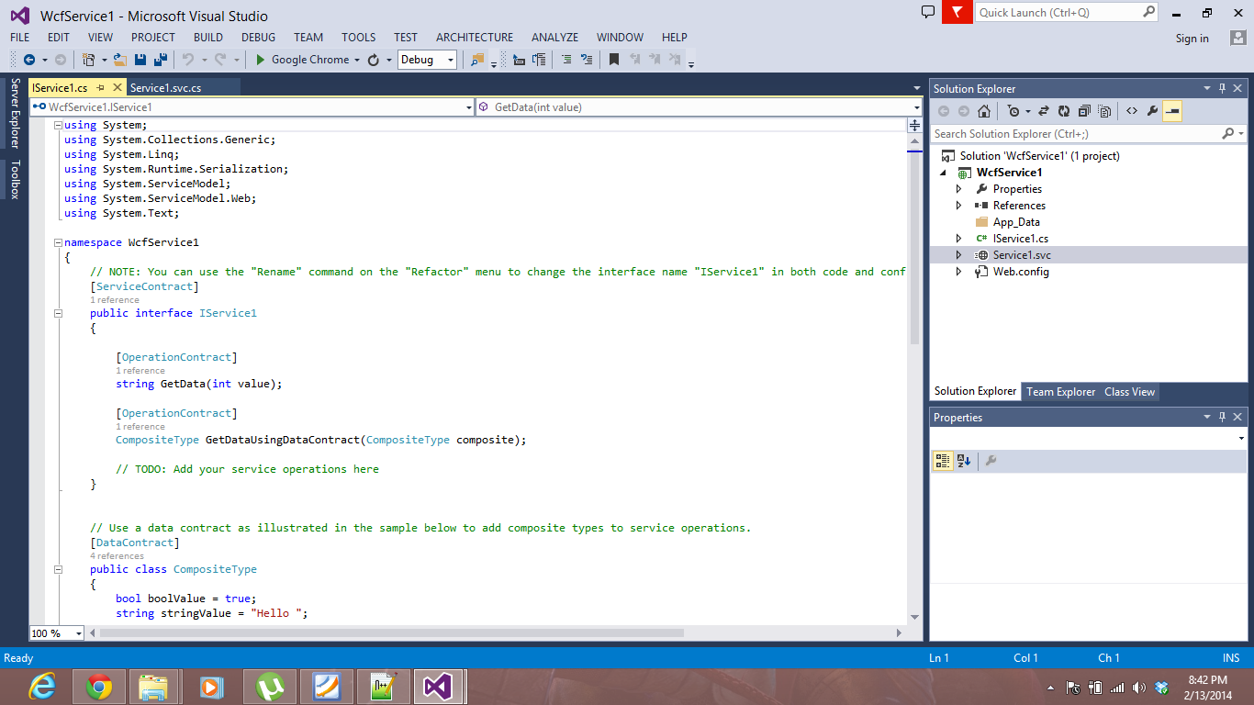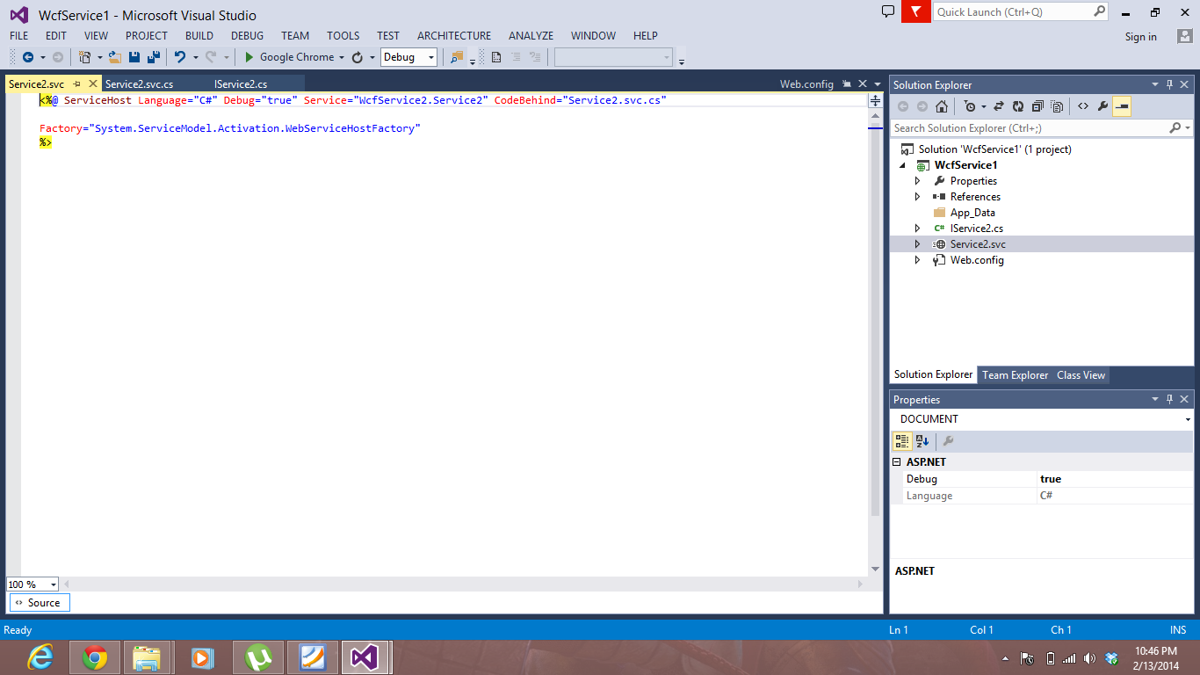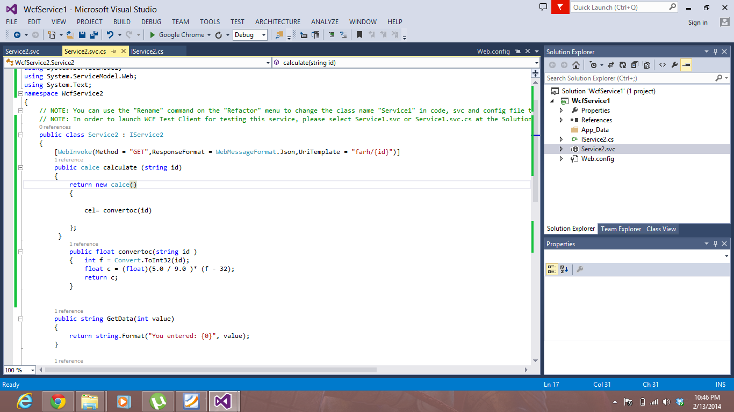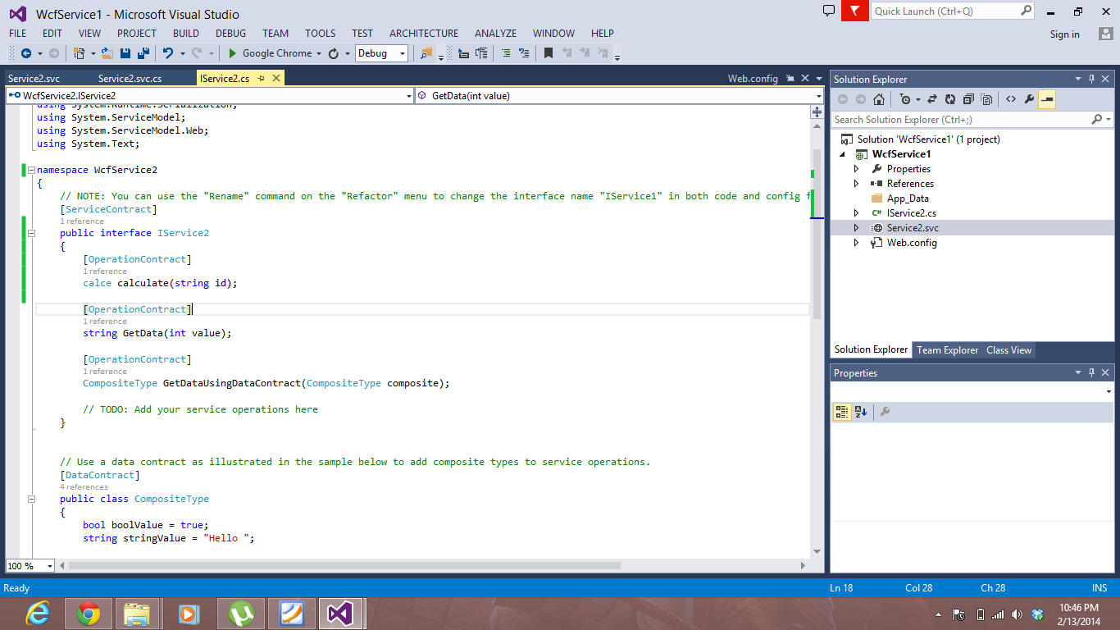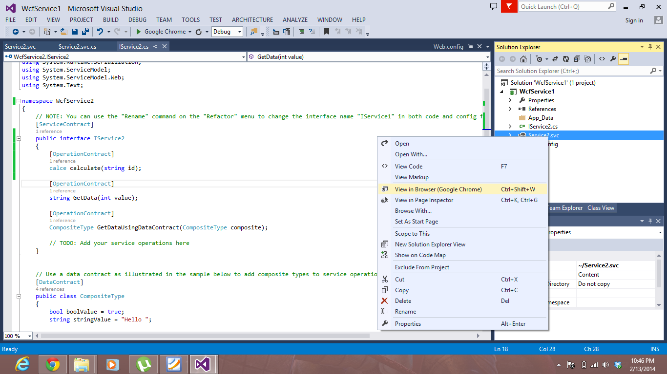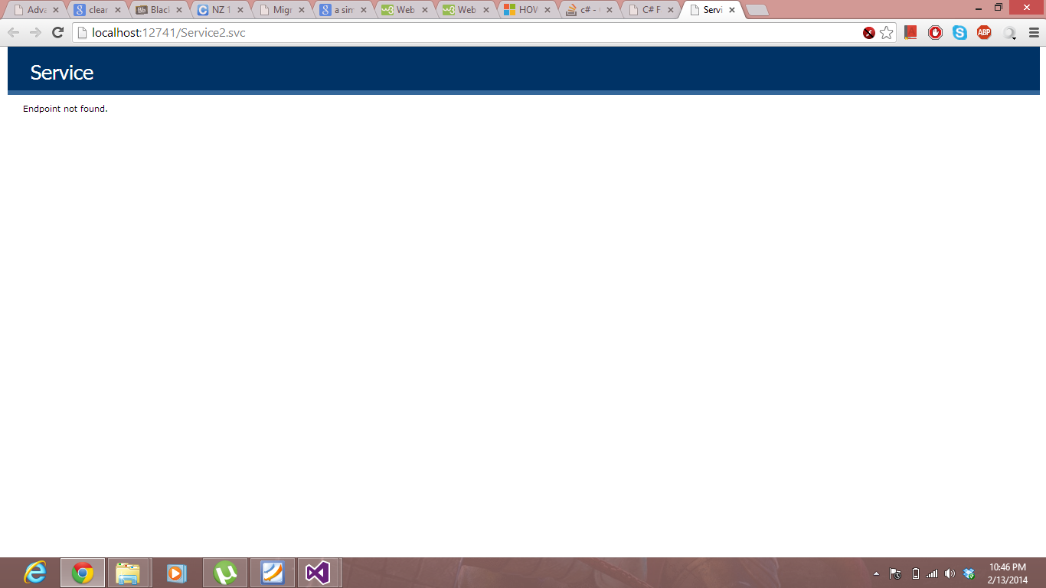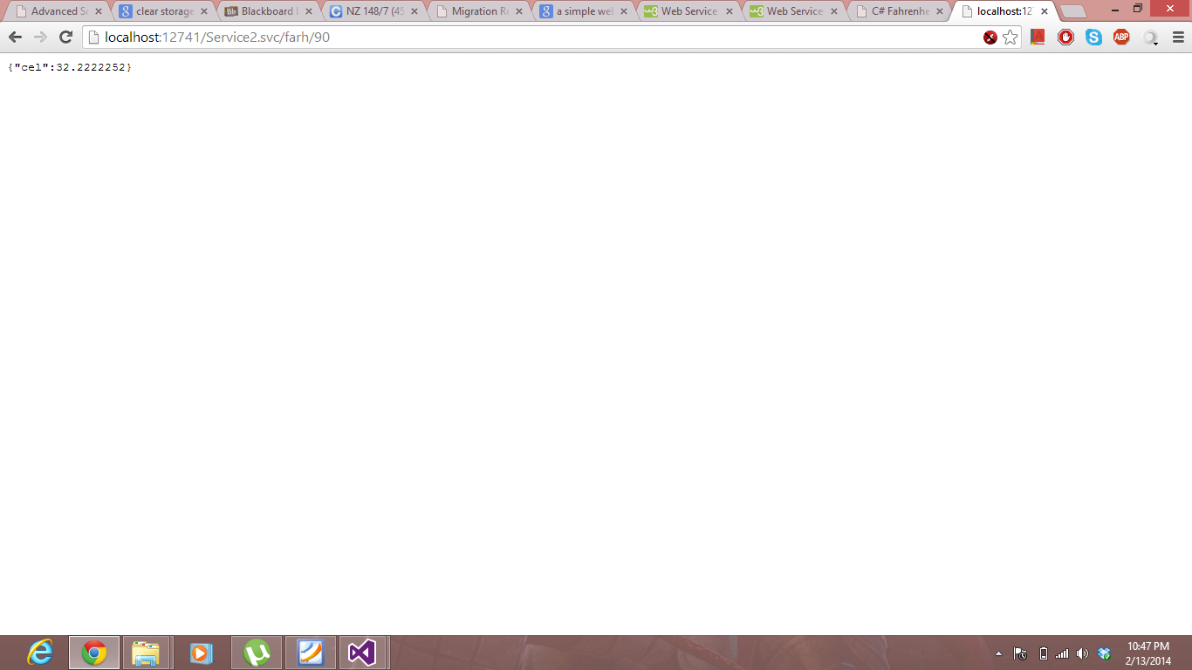

Now using the REST service I developed a web Client which takes the Fahrenheit and gives the Celsius as an alert using Jsfiddle. This can be shown in the screen shots below.

